**II. WHY AGILE**

Introduction

Lesson Introduction

Welcome to the lesson on why Agile has taken the market by storm in today's digital age.

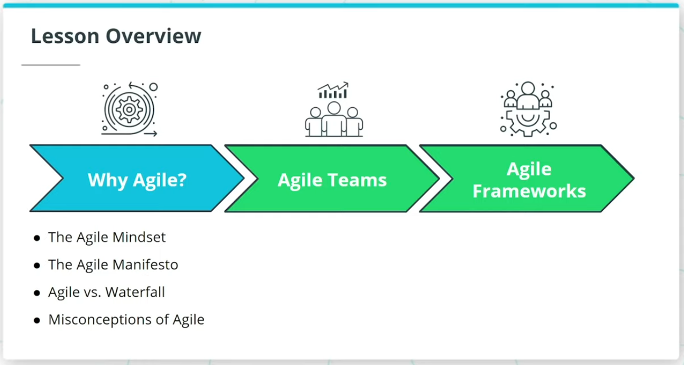

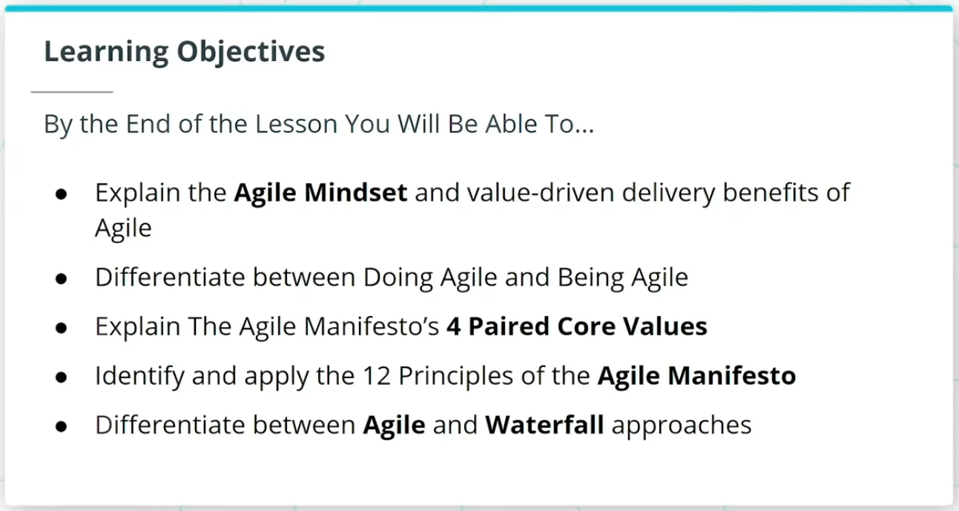

### **What We Will Cover In This Lesson**

In this lesson, we will focus on the foundational theory behind Agile. We will discuss:

* The Agile Mindset and how it sets the tone for ‘Being’ Agile versus just ‘Doing’ Agile
* The Agile Manifesto, and how it is seen as the foundational set of 4 Paired Core Values and 12 Principles that sets the foundation for all Agile Frameworks
* How Agile differs from the more traditional Waterfall approach to product development

We will wrap up the lesson with an important discussion on common misconceptions about Agile.

### **By the End of the Lesson, You Will Be Able To...**

* Explain the Agile Mindset and value-driven delivery benefits of Agile
* Differentiate between Doing Agile and Being Agile
* Explain The Agile Manifesto’s 4 Paired Core Values
* Identify and apply the 12 Principles of the Agile Manifesto
* Differentiate between Agile and Waterfall approaches

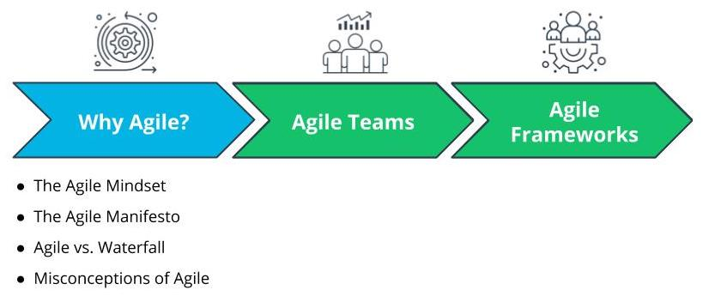

What We Will Cover In This Lesson